Chapter 1: Problem Definition

The number of smartphone users and mobile application offerings is growing rapidly. Recent smartphones can offer personal computer like functionality and are sometimes used as substitutes for laptop computers. Moreover, with the advent of Android, the first open source and fully customizable smartphone operating system (OS), developers of smartphone applications now have unprecedented freedom to create killer applications that were unimaginable before. The downside of this trend, however, is that smart-phones are expected to suffer increasing security risks from malware and data leakage in much the same way as personal computers today.
The fact that Smartphones still have limited processors, processing power and battery life further complicates the problem since Conventional counter measures such as anti-virus programs can seriously hamper the usability of smart-phones. Recent smartphones can offer personal computer like functionality as a whole but still they cannot offer same performance of present day advance processors and application developers are forced to take these limitations into consideration. hence We are developing a system that provides a cloud computing environment specifically designed to extend the capacity of smartphones. It is called as “JVM Based Cloud Computing for Android”.

Chapter 2: Literature Survey

Our project idea, ‘JVM Based Cloud Computing for Android’ comes from Dropbox & Zumodrive software. Most of the knowledge about the project we got from Microsoft documents and IEEE paper of Implementation of “Virtual Smartphone Over IP”. Various algorithms related to Virtual Smartphone Over IP system were known from the PDF documents downloaded from internet.

Existing Systems

There are various service providers like Dropbox and Zumodrive, they provide online storage of data which is easily accessible from any machine irrespective of platform as they are web based. Here, only storage is given to the user which is retrieved later. Other services like Google Doc, Gmail are implemted through cloud computing they use SAAS flavour of cloud computing.

Basic Idea of System

As mentioned above there are services offered through cloud computing but there are no services which offer customized/particular user applications to run on cloud, personal computers cope with this problem by local installation of applications due their high end processors, large abundant memory and constant power supply, but when smartphone are considered this is a mojor problem because of processor speed and memory constraints.

Cloud – It has 3 different flavors SAAS, PAAS & IAAS

SAAS - Clients can use the software provided by provider. Which usually need not to install and it is usually a one to many service. Like Gmail, search engine.

PAAS - Clients can run their own applications on the platform provided; General platforms are Linux and Windows.

IAAS - Client can put their own operation system on cloud. For example, user can put an optimized Linux for networking ability. In practical usage, PaaS and IaaS are actually very similar with the difference that whether the image is provided by user or not. If you use the image provided, it is PaaS, otherwise, it is IaaS.

Hence By creating a PAAS component we will run our own applications on cloud.

Android Developers & x86 project

Andriod developers is a community of developers where all new projects are discussed, the basis of our project of what application is to be designed and what are the criterias,need and parameters to be followed is understood.
Android x86 project is, to run android applications on desktop machines for this a android desktop operating system is also being developed.

Other similar Projects under Development

Cloudlet - Mobile users seamlessly utilize nearby computers to obtain the resources of cloud computing by instantiates a "cloudlet" that rapidly synthesizes virtual machines on nearby infrastructure that can be access through WLAN.

MobiDesk - A virtual desktop computing hosting infrastructure that provides full featured PC desktop environment to mobile users.

Chapter 3: Software Requirements Specification

3.1 Introduction

3.1.1 Project scope

The scope of this project includes Android 1.6 and later users, and is primarily intended to allow users to quickly and easily access application they’re looking for. The project will provide a messaging system for users to communicate with each other. However later revisions can include a no of applications as required built on Android SDK and on cloud deployed through JVM.

3.1.2 User Classes and Characteristics

1. A good knowledge of smartphone
2. Heavy smart phone user
3. Business user
4. Marketing user
5. Meeting planner
6. Heavy e-mail user
7. Onsite/field user
3.1.3 Operating Environment

The software will operate on any Android based smart phone which will connect to private cloud deployed through JVM.
The system will primarily be developed and tested on windows based Operating Systems. But our goal is to make it a platform independent solution. The target platforms are:
• Linux
• Microsoft Windows
• Mac OS.

3.1.4 Design & Implementation constraints

1. Since we are only developing the software for Android based smartphones, it will not be available for iPhone and BlackBerry users.

2. Good battery backup.
3. Dynamically adjusting screen size.
4. Smartphone should be EDGE enable, for better results 3G enable.

3.1.5 Assumptions and Dependencies

1. Battery backup should be at least 10%.
2. Screen size of smartphone should be minimum of 2.5 inches.
3. Restriction of license duration only date based not through usages.

3.2 System Features

3.2.1 Sensor readings

Most modern smartphones are equipped with various sensors such as a GPS (global positioning system) device, accelerometer, orientation sensor, magnetic field sensor, and thermometer. While most conventional thin-client solutions support only the key-board and mouse as primarily input devices, our sys-tem allows applications installed in a virtual smart-phone to access a physical smartphone’s sensor readings. The sensors appear as if they were mounted directly on the remote virtual smartphone. As more and more mobile applications take advantage of these devices, this will become an important feature for seamlessly running applications in a virtual remote environment.

3.2.2 GUI integration

Our system allows applications running in the cloud to appear like native applications on the physical device with graphical-user-interface (GUI) functions such as copy & paste between local and remote applications. It also features shortcuts to remote applications in the virtual smartphone that minimize the steps required for users to launch remote applications. Furthermore, each shortcut can be bound to a different virtual smartphone, which allows users instant access to remote applications residing in multiple virtual smartphones in a single menu.

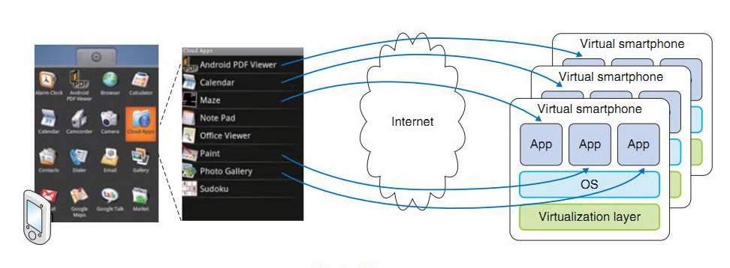

3.2.3 Relocation of applications

Another innovative feature is the ability to relocate applications and their associated data between a remote virtual smartphone and a local physical smart-phone. This gives smartphone users a new degree of freedom in managing their mobile applications.
3.3 External Interface Requirements

3.3.1 User Interface

There will be 2 User Interface in our project.
1. Level 1 user - API developer

This user will create the API’s for Level 2 user to work on and build a framework which will support Applications.

2. Level 2 user – Application Developer

Applications will be developed by this user for Android OS

3.3.2 Hardware Interfaces

The physical characteristic of the interface being used is the touch screen on any Android smart phone. The user will be required to use the touch screen. Keypads or other forms on user input will not be valid means of accessing data through our software.

- Open source EJP container
- Android OS based Smartphone
- Processor: Pentium IV

3.3.3 Software Interfaces

The application will be run on the Android OS, and as such, any input given to the touch screen will directly interact with the underlying OS, which will act as input to the software. All of the data required for the application will be stored within the application itself. Each user will have a copy of the data stored within their phone once the application is installed.

- Eclipse
- JDK
- Any UI based Operating system
- Windows XP /VISTA/07

3.3.4 Communication Interface

1. 3G
2. H3G Protocol
3. HTTP Protocol

3.4 Nonfunctional Requirements

3.4.1 Performance Requirements

1. The output will display on the screen in real time as depending on the internet connection as only sending of graphic pixels will be there.

2. The software will implement an intuitive and easy to use interface.

3. Graphically appealing to the user.

3.4.2 Safety and Security Requirements

Access will be given to user after username and password validation to use applications. All applications will have their virtual images in the cloud and their instance will be there on smartphones.

3.4.3 Software Quality Attributes

Reliability
After rigorous testing, we will ensure our program is reliable as program does not travel outside cloud server it is reliable.

Usability
The software will be highly intuitive, with a very low learning curve.

Portability
Our software will be highly portable amongst Android phones. It can be used from any android smartphone device as it will have its virtual images in the cloud.

Reusability
Our software will be able to be reused also if updation is done in it. Any changes done in it will not hamper the cloud environment where it is located. Changes would need to be made if the Android O/S became obsolete or non-functional and the same can be said if the use of touch screens in the Android is no longer the norm.

3.4.5 Mathematical Model

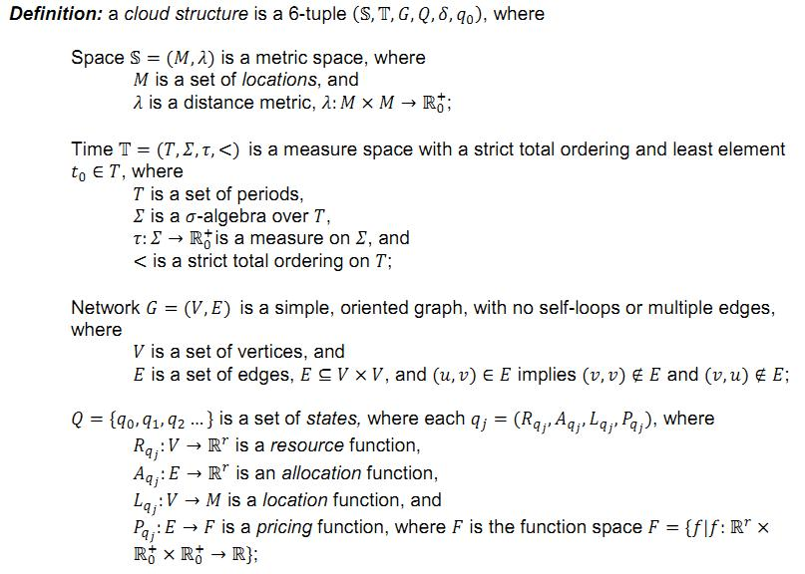

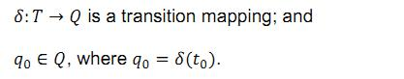
3.5 Analysis Models

Class Diagram

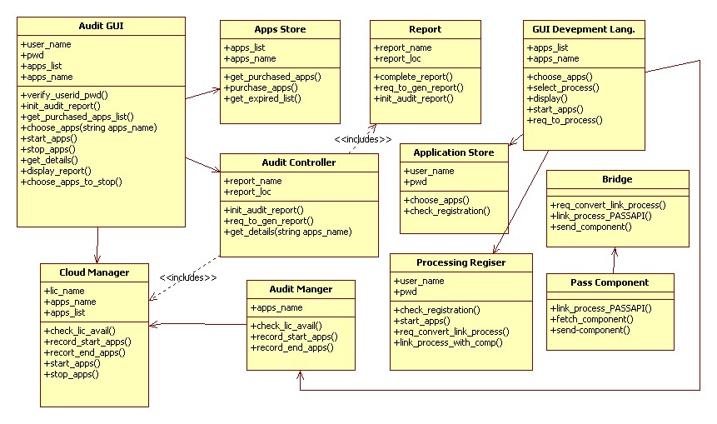

State-transition Diagrams

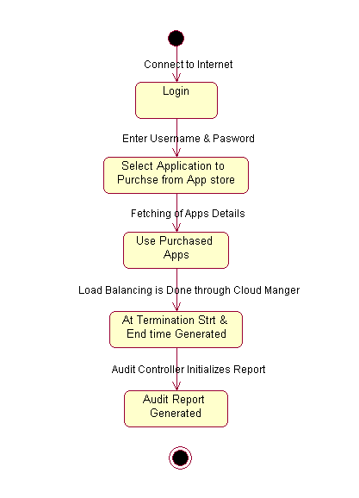

3.6 System Implementation Plan

Month | Schedule | Project task
July | 1st Week | Idea about Project Selection/Project Topic Selection
July | 3rd Week | Submission of Project Synopsis/Abstract
July | 5th Week | Guide Allocation & Literature Survey
August | 1st Week | To Display List of Project Groups with Guide Names
August | 2nd Week | First presentation with Guide about idea of projects (Feasibility study)
August | 3rd & 4th Week | Requirement Analysis (SRS Document) Preparation & Submission
September | 1st Week | Design of Project-Low level, High Level, Data Structure, Database tables & Algorithms
September | 3rd Week | Presentation –II with design
September | 4th Week | Preparation of preliminary report
October | 1st Week | Submission-Prelim Report of the Project
November | 2nd Week | University Exam on Preliminary Report
Chapter 4: System Design

4.1 System Architecture

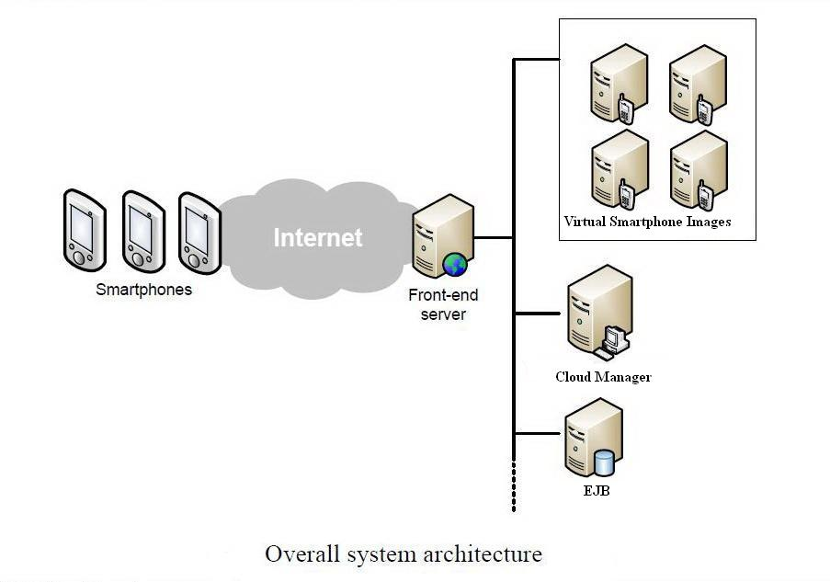

4.2 UML Diagrams

1. Use Case diagram
2. Activity diagram
3. Sequence diagram
4. Deployment diagram
5. Collaboration Diagram

1. Use Case Diagram

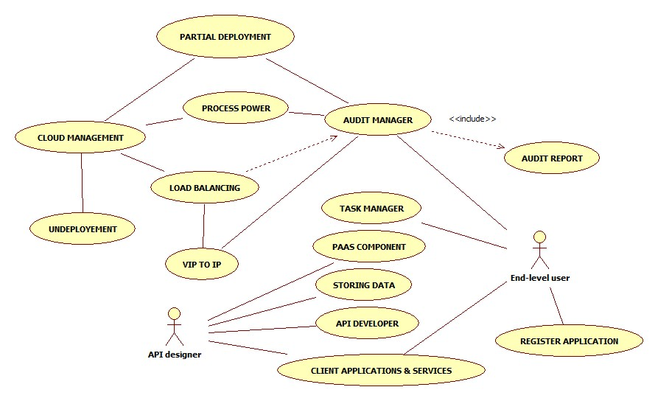

2. Activity Diagram

1. PAAS Component Diagram
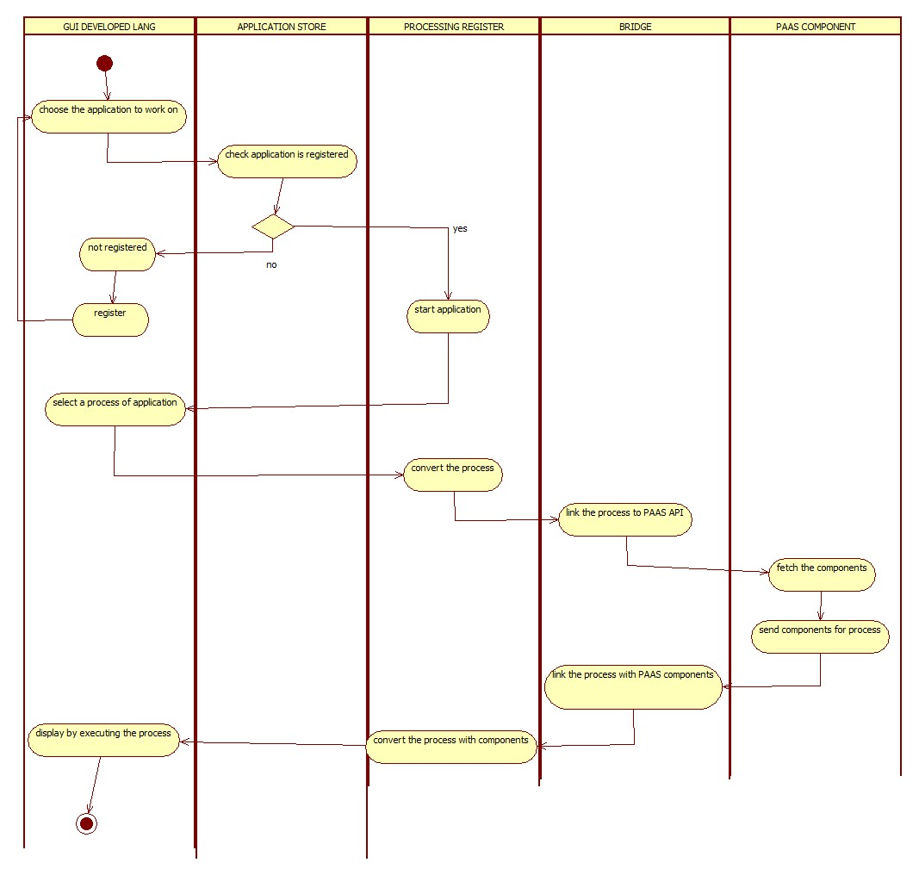

2. Audit Controller Diagram
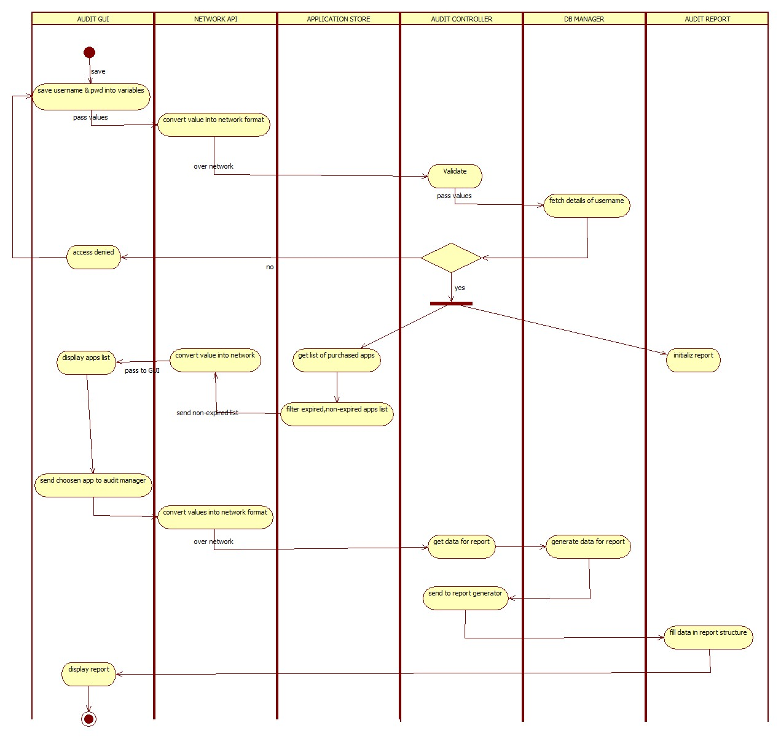

3. Task Manager Diagram
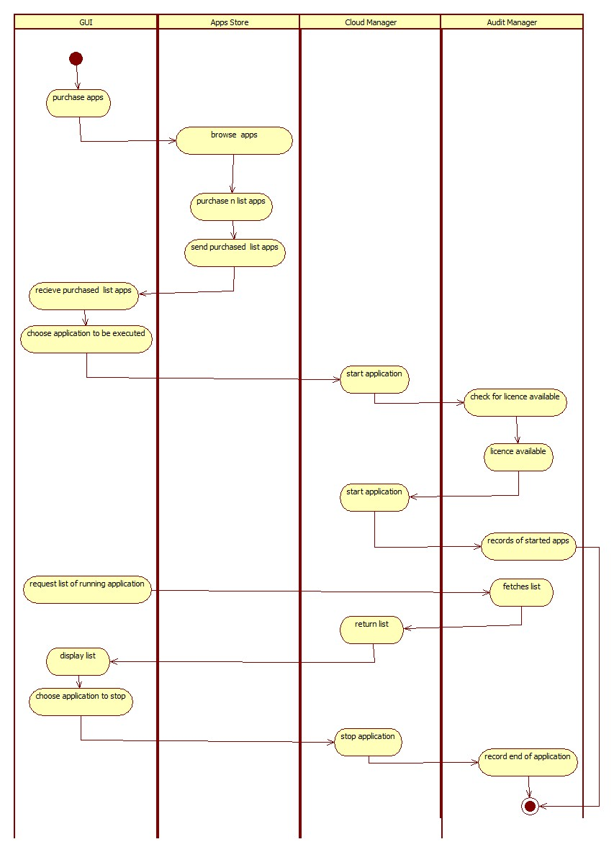

4. Bridge Diagram
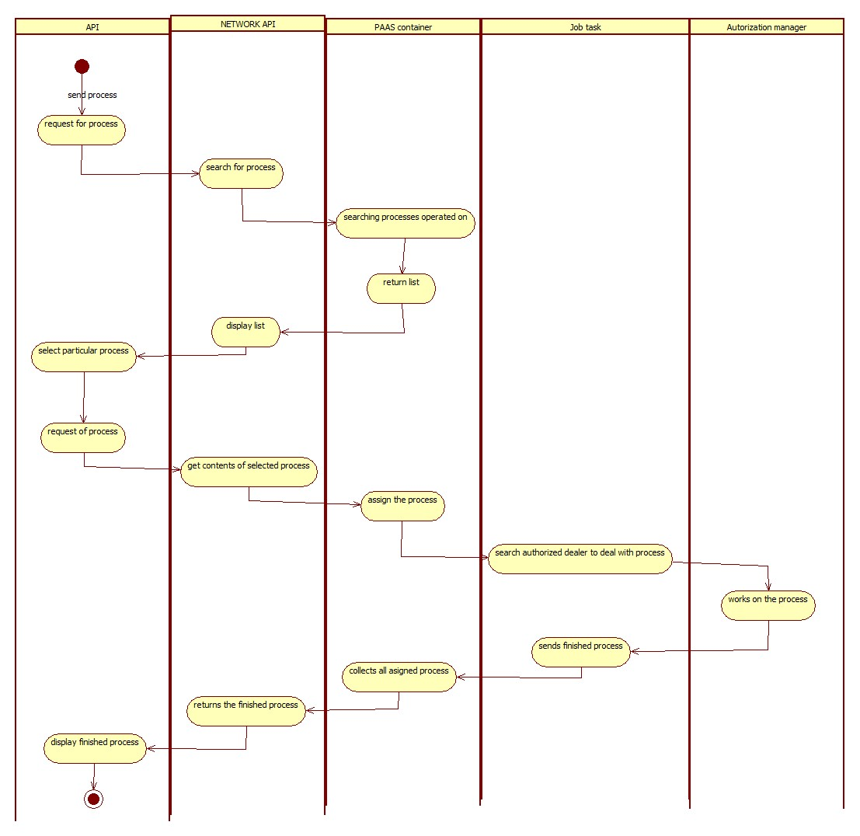

3. Sequence Diagram

1. Audit Controller Diagram
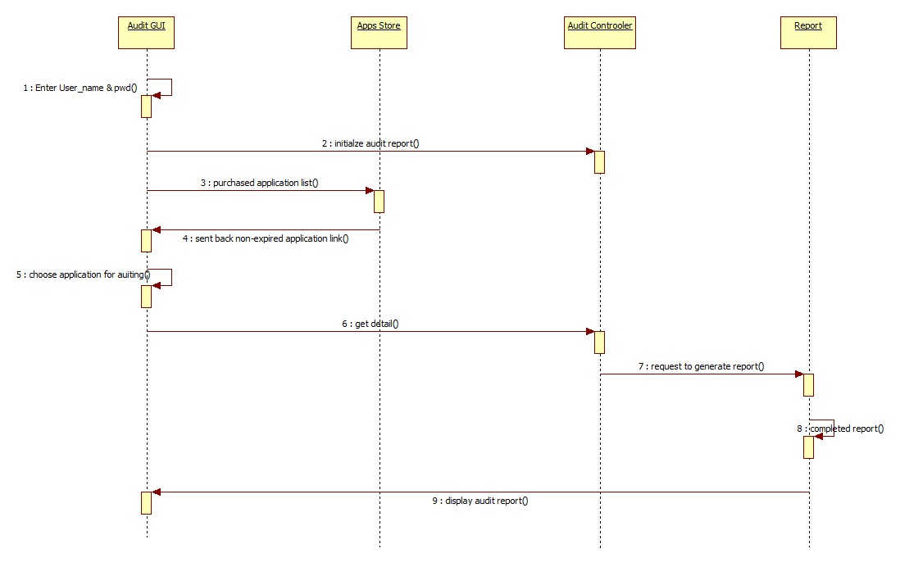

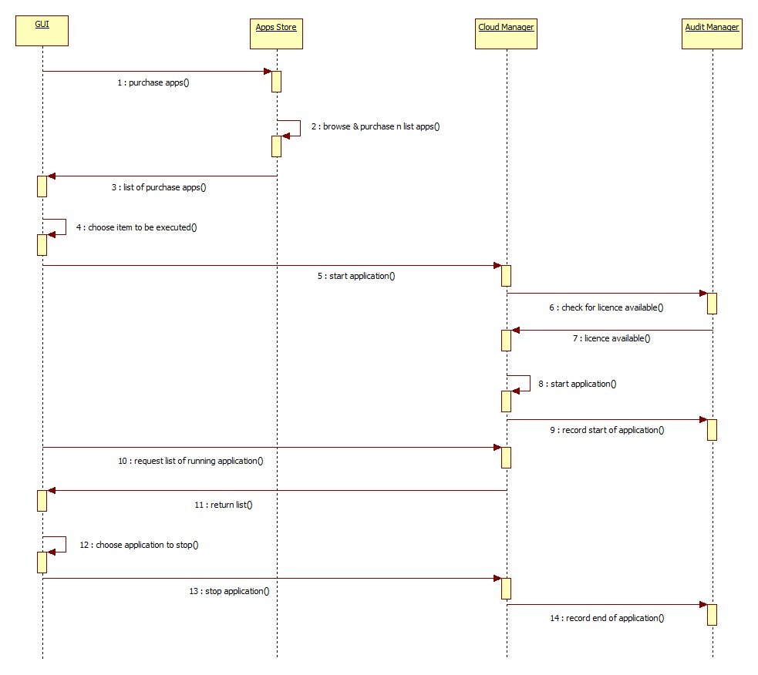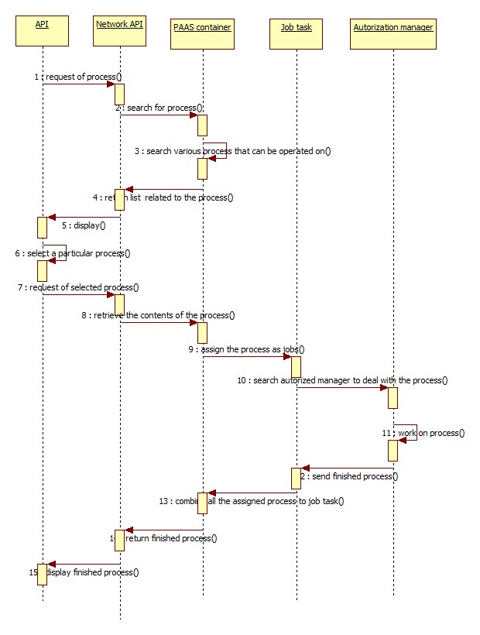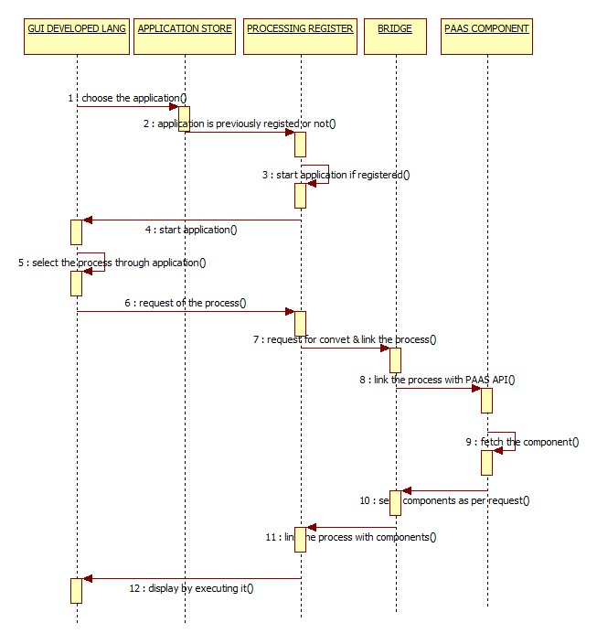

4. Deployment Diagram

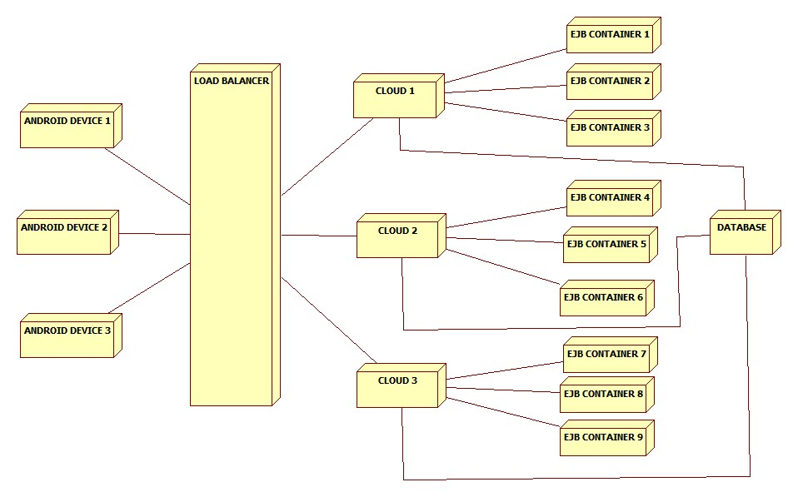

5. Collaboration Diagram

PAAS Component Diagram

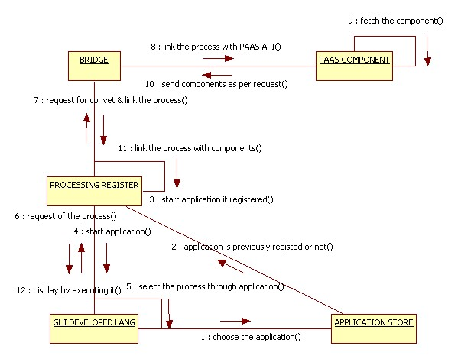

Bridge Diagram

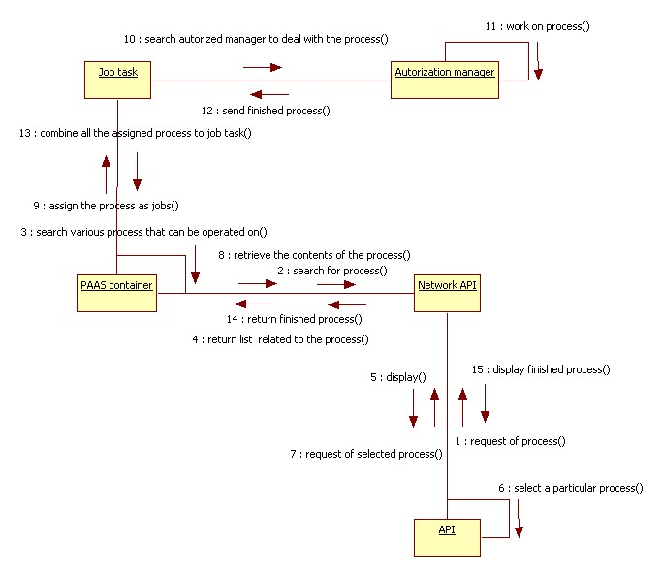

Audit Controller Diagram

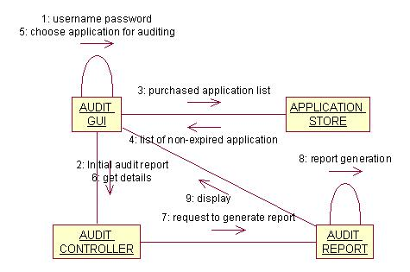

Task Manager Diagram
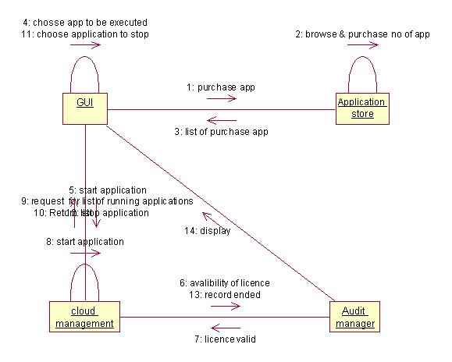
Chapter 5: Technical Specification

5.1 Advantages

1. Computing power

The performance of mobile applications can be drastically leveraged by executing them in a virtual smartphone image hosted in the cloud.

2. Battery consumption

The system is helpful in conserving device batteries by moving computation intensive applications to the cloud.

3. Traffic rate

One of the advantages of allowing users to use a remote virtual smartphone image is its small screen output size. The smaller the screen size, the smaller the amount of data traffic involved in transmitting the graphic pixels of display images across the network.

5.2 Disadvantage

1. Our project is dependent on the network technologies if network fails operations are blocked.

2. If cloud failure is there then whole system will go down.

3. It is compatible with only Android smartphones.

5.3 Applications

1. Remote sandbox

A virtual smartphone image can be used to execute unknown mobile applications from unverified third parties. This environment is conventionally called a sandbox because applications do not run natively on the physical device and can access only a tightly con-trolled set of remote resources visible from the virtual smartphone image. Network and data access is heavily restricted to minimize possible negative impacts of potentially harmful applications. A sand-box is particularly useful for Android users who would like to install the less-trusted applications obtained outside the official Android Market.

2. Data leakage prevention

Our system can also be used as a viable solution against data leakage if the data is stored in the data center and accessible only through one of the virtual smartphone images. Since only the graphic pixels of display images are transferred to the physical smartphone, corporate data is securely contained within the data center and never stored in the physical smartphone. This allows employees to work with the data remotely and securely without retaining it on their devices.

3. Performance boost

The fact that Android will use the same Java application framework on both x86 and ARM processors through our private cloud deployed JVM provides seamless application portability on these platforms. We can boost the performance of Android applications by running them on x86 platforms with the vast resources of cloud computing.

4. Other possibilities

There are many other ways to use our system. It can be used to archive the less frequently used applications and free up storage space on physical smartphones. It can help users prevent their local device from accumulating unwanted residual files from trial applications. Android applications sometimes leave residual files even after they have been uninstalled by the user.
Chapter 6: Appendix A

Acronyms and Abbreviations

API - Application Program Interface
JVM - Java Virtual Machine
SAAS- Software As a Service
PAAS - Platform As a Service
IAAS- Infrastructure As a Service
EJB – Enterprise Java Beans
VM – Virtual Machine
SDK – Standard Development Kit
NFS – Network File System
HTTP – Hyper Text Transfer Protocol
OS – Operating System
JDK – Java Development Kit

Chapter 7: Bibliography

Books

1. Cloud Computing for Dummies
2. Enterprise Cloud Computing
3. Android: The Developers Guide
4. JAVA Complete Reference

Websites

www.google.com

http://developer.android.com/index.html

